Script Reference & User Guide
Comparative Evaluation of Vision-Based Finger Tracking for Piano Interaction

1. Pipeline Overview
The system is structured as a sequential pipeline. Each script hands off its output to the next stage. live_preview.py is a standalone tool that does not persist any data.

key_calibration.py run once per camera/tripod position
|
record.py capture video + MIDI per participant
|
recalibrate.py (optional) fix calibration on saved video
|
analyse.py compute MPJPE results per session
|
plot_results.py generate group charts and participant reports

live_preview.py standalone live test (no data written to disk)
data_summary.py audit data/raw/ session counts at any time

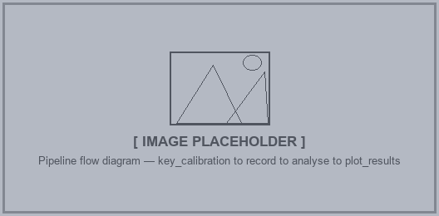
Pipeline flow diagram — key_calibration to record to analyse to plot_results

2. config.py
Purpose: Central store for every tunable constant in the project. All other scripts import this instead of hard-coding values.
Depends on: nothing (no internal imports)
Used by: all scripts

Key constants
Constant | Description
CAP_WIDTH / HEIGHT / FPS | Camera capture resolution and target frame rate
RESIZE_WIDTH / HEIGHT | Resolution MediaPipe runs inference at (smaller = faster)
MODEL_COMPLEXITY | MediaPipe model complexity (0 = lite, 1 = full)
MIN_DETECTION_CONFIDENCE | Minimum score to accept a hand detection
MIN_TRACKING_CONFIDENCE | Minimum score to continue tracking a detected hand
LUX_DIM_THRESHOLD | Below this value (lux) the session is labelled Dim
LUX_BRIGHT_THRESHOLD | At or above this value the session is labelled Bright
HAND_SIZE_MIN / MAX_CM | Validation range for the manually entered hand length
HAND_SIZE_SMALL_MAX_CM | Hand lengths below this are categorised as Small
HAND_SIZE_LARGE_MIN_CM | Hand lengths at or above this are categorised as Large
ACCURACY_THRESHOLD_RATIO | Fraction of white key width used as the accuracy pass threshold
MASK_* | Fill and border colours for the keyboard overlay drawn on-screen

3. Support Scripts
These scripts are imported by the main pipeline scripts. They are not run directly.

3.1 camera_setup.py
Purpose: Opens the camera with the correct backend for the current OS and applies the capture resolution and FPS from config. Returns a ready VideoCapture object.
Depends on: config, cv2
Used by: record.py, key_calibration.py, live_preview.py

Key function:
- init_camera(config) — opens the camera using CAP_DSHOW on Windows (required to avoid DirectShow double-open conflicts), sets width/height/FPS and buffer size, returns the VideoCapture handle.

3.2 lux_calculator.py
Purpose: Converts a numeric lux value into a human-readable lighting category label.
Depends on: config
Used by: record.py, live_preview.py

Key function:
- lux_to_label(lux) -> "Dim" / "Indoor" / "Bright" (thresholds are set in config.py)

3.3 fitzpatrick_detector.py
Purpose: Estimates the participant's Fitzpatrick skin type (I-VI) from a live video frame using the ITA (Individual Typology Angle) colorimetric method. Samples CIELab pixels from the palm convex hull (landmarks 0,1,5,9,13,17). Runs once per session at setup time.
Depends on: config, cv2, numpy
Used by: record.py

Key functions:
- detect_skin_type(frame, hand_landmarks, fw, fh) -> (fitzpatrick_type, label, ita_angle) or (None, None, None) if palm not visible
- ita_to_fitzpatrick(ita) -> (type_int, label_str) — maps ITA angle to the six Fitzpatrick categories using Chardon (1991) thresholds

3.4 stats_collector.py
Purpose: Rolling statistics tracker for the recording/preview loop. Computes FPS, MediaPipe inference time, and total frame latency over a configurable window.
Depends on: numpy, collections.deque
Used by: record.py, live_preview.py

Key class: StatsCollector(warmup_frames, stat_frames)
Method / property | Description
update(loop_start, inference_ms, latency_ms) | Call once per frame to push new measurements
fps | Rolling average frames per second
inference_ms | Rolling average MediaPipe inference time (ms)
latency_ms | Rolling average total frame latency (ms)
warmup_done | True once warmup_frames have elapsed
print_final_stats(w, h, complexity) | Prints a summary table on session exit

3.5 midi_recorder.py
Purpose: Threaded MIDI input capture with time.perf_counter() timestamps. All timestamps are relative to a shared t0 set at recording start (SPACE keypress), keeping video and MIDI in sync.
Depends on: mido, python-rtmidi, json, threading, pathlib
Used by: record.py, live_preview.py

Key classes:
Class / function | Description
MidiRecorder.start(t0) | Begins background daemon thread polling the MIDI port every 1 ms. Skips realtime messages (clock, active sensing).
MidiRecorder.stop() | Joins the background thread.
MidiRecorder.save(out_dir, pid_str) | Writes p###_midi.jsonl (one JSON line per event) and p###_midi.mid (standard MIDI file, type 0, 120 BPM).
FrameLogger.log() | Call once per writer.write(frame). Records (frame_index, time_s) relative to t0.
FrameLogger.save(out_dir, pid_str) | Writes p###_frames.csv.
list_midi_input_ports() | Returns list of detected MIDI port name strings.

3.6 model_manager.py
Purpose: Abstract interface and concrete wrappers for switching between hand-tracking models at runtime. Defines a common API (load, infer, draw, close) so analyse.py can run either model without branching logic.
Depends on: config, cv2, numpy, mediapipe
Used by: live_preview.py, analyse.py

Concrete model classes:
- MediaPipeHandModel — wraps mp.solutions.hands. infer() returns the standard MediaPipe result object.
- OpenPoseHandModel — loads pre-trained Caffe weights via cv2.dnn. infer() extracts 21 keypoints from heatmap outputs. Operates on a keyboard-area crop rather than the full frame.

4. key_calibration.py
Purpose: Interactive GUI for aligning a virtual piano keyboard overlay over the camera view. The overlay geometry (position, key width/height, perspective warp) is saved to data/calibration/key_centers.json and loaded by all downstream scripts.
Depends on: config, camera_setup, cv2, numpy, json, math
Used by: record.py, live_preview.py, analyse.py, recalibrate.py

Key class: KeyMask
Method | Description
draw(frame, center_viz='line') | Blends the perspective-warped key overlay onto a frame in-place. center_viz='line' draws a full-depth vertical line per key; 'dot' draws a single point at the calculated centre.
on_mouse(event, x, y, flags) | Handles drag-to-move, edge-drag-to-resize, corner-drag-to-warp, scroll-to-add/remove keys.
save(cal_dir, fw, fh) | Writes key_centers.json with layout parameters and pre-computed per-key centre coordinates.
KeyMask.load(path) | Reconstructs a KeyMask from a saved JSON file.
KeyMask.default(fw, fh) | Returns a default 29-key layout sized to ~3/4 frame width.

Exported utility function:
- build_key_layout(start_midi, num_white, ox, oy, wkw, wkh) — re-derives per-key centre coordinates from saved parameters; used by analyse.py and recalibrate.py.

Controls
Key / Action | Effect
Drag interior | Move the entire keyboard overlay
Drag left / right edge | Resize key width (opposite edge stays fixed)
Drag bottom edge | Resize key height
Drag corner circle | Warp perspective to correct camera angle
Scroll wheel | Add or remove one key on the right end
[ / ] | Shift the starting MIDI note down / up
- / = | Fine key width -1 / +1 px
C | Toggle centre visualisation (line / dot)
F | Toggle 180 degree flip to match record.py orientation
H | Toggle on-screen help
V | Reset perspective warp to rectangle
ENTER or S | Save calibration to key_centers.json
ESC | Quit without saving

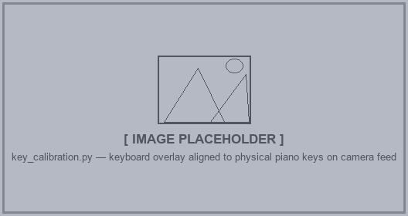
key_calibration.py — keyboard overlay aligned to physical piano keys on camera feed
INFO Run key_calibration.py first, or any time the camera or tripod position changes. All downstream scripts rely on the saved key_centers.json.

5. record.py
Purpose: Main data collection script. Displays a live MediaPipe hand-tracking preview with the key overlay active. Before each participant, a setup screen collects participant ID, Fitzpatrick skin type, ambient lux, and hand size. Pressing SPACE starts and stops recording.
Depends on: config, camera_setup, fitzpatrick_detector, lux_calculator, stats_collector, midi_recorder, key_calibration, mediapipe, cv2, numpy, mido
Used by: (main script — not imported by others)

Output files per session (data/raw/p###/)
File | Contents
p###.mp4 | Raw video with no overlays. 180 degree flip baked in if flip_y = True.
p###_frames.csv | frame_index, time_s — one row per recorded frame, timestamps relative to recording start.
p###_midi.jsonl | One JSON line per MIDI event with time_s offset from recording start.
p###_midi.mid | Standard MIDI file (type 0, 120 BPM, 480 ticks/beat).
p###_session.json | Session metadata: lux, hand size, Fitzpatrick type, flip state, MIDI port name, and references to all output file names.
p###_key_centers.json | Snapshot of the active calibration at the moment recording started.

Key controls
Key | Action
SPACE | Start recording / stop recording
N | Finish session and go to setup screen for next participant
M | Toggle key overlay visibility
P | Toggle mask control panel (move/resize overlay with buttons)
C | Toggle centre visualisation (line / dot)
S | Toggle FPS / inference / latency stats overlay
R | Re-run Fitzpatrick skin-type auto-detection
F | Toggle 180 degree frame flip
V | Reset mask perspective warp to rectangle
ESC | Quit

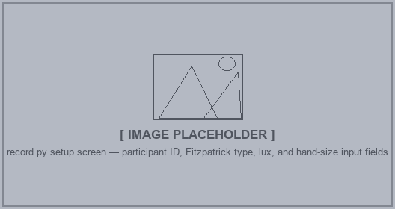
record.py setup screen — participant ID, Fitzpatrick type, lux, and hand-size input fields
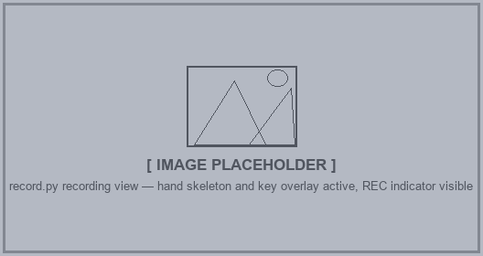
record.py recording view — hand skeleton and key overlay active, REC indicator visible

6. live_preview.py
Purpose: Live hand-tracking preview and real-time MPJPE accuracy test. Mirrors record.py's display but writes nothing to disk. Shows live MPJPE, accuracy percentage, and detection rate in the top-right corner. On exit (ESC), displays a full results panel with per-finger breakdown.
Depends on: config, camera_setup, key_calibration, midi_recorder, stats_collector, mediapipe, PIL, cv2, numpy, mido
Used by: (standalone tool — not imported by others)

MPJPE computation
For every MIDI note_on event (velocity > 0) while at least one hand is visible, the script classifies the outcome into one of three categories:
Outcome | Meaning | Effect on MPJPE
matched | A fingertip landmark was inside the key polygon | Horizontal error |tip_x - key_cx| added to MPJPE
detection_fail | Hands visible but no fingertip tip inside the polygon | Counted separately — NOT added to MPJPE
missed | No hand landmarks detected at all | Counted separately — NOT added to MPJPE

INFO MPJPE uses horizontal-only error (|tip_x - key_cx|) to remove depth / finger-length bias from the measurement. Any fingertip Y position within the key height is considered correct.

Key controls
Key | Action
M | Toggle key mask overlay
N | Toggle mask control panel
C | Toggle centre visualisation (line / dot)
S | Toggle FPS / inference / latency stats overlay
V | Reset perspective warp to rectangle
ESC | Stop test and show results panel

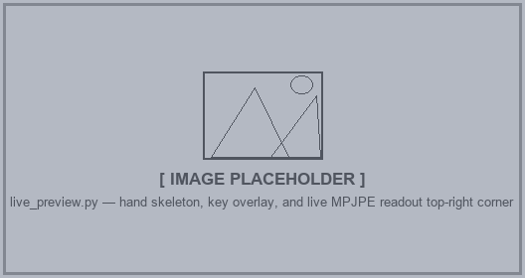
live_preview.py — hand skeleton, key overlay, and live MPJPE readout top-right corner
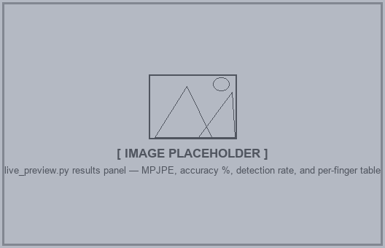
live_preview.py results panel — MPJPE, accuracy %, detection rate, and per-finger table

7. recalibrate.py
Purpose: GUI tool for aligning the key overlay against a pre-recorded session video. Useful when the session calibration file was lost or was inaccurate. Saves a per-session p###_key_centers.json that analyse.py will prefer over the global calibration.
Depends on: key_calibration.KeyMask, cv2, numpy, json, csv
Used by: (standalone tool — run manually before re-analysing a session)

Workflow
1. Run python -m scripts.recalibrate to open the participant picker.
2. A scrollable list of all data/raw/p###/ folders is shown. Green dot = already has a per-session calibration. Blue dot = will use the global calibration.
3. Click a participant to open the calibration editor, which plays back that session's video.
4. Align the overlay to match the piano in the video. The NOW: C5 indicator shows which MIDI note was played at the current frame.
5. Press ENTER or S to save p###_key_centers.json and return to the picker.


recalibrate.py participant picker — scrollable list with green/blue status dots
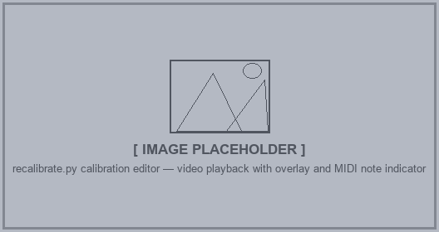
recalibrate.py calibration editor — video playback with overlay and MIDI note indicator

8. analyse.py
Purpose: Offline per-session MPJPE computation. For each note_on event in the MIDI log, it seeks to the nearest video frame, runs the chosen model, and records the outcome. Supports MediaPipe and OpenPose via model_manager. Can be run from the command line or via a Tkinter GUI session picker.
Depends on: config, key_calibration.KeyMask, model_manager, mediapipe, cv2, numpy
Used by: (main analysis script — outputs consumed by plot_results.py)

Calibration priority
analyse.py looks for a per-session calibration file first (data/raw/p###/p###_key_centers.json), then falls back to the global calibration (data/calibration/key_centers.json). Use recalibrate.py to create per-session files where needed.

Hand classification
- MediaPipe: uses multi_handedness label combined with thumb-MCP-to-wrist geometry to determine physical L / R, accounting for mirrored camera setups.
- OpenPose: geometry is unreliable on scene-level crops; falls back to keyboard-position split (left of keyboard midpoint = L).

Output files (data/processed/p###/)
File | Contents
p###_mediapipe_results.json | Per-session MPJPE results: detection_rate_pct, per_hand L/R with matched, detection_fail, mpjpe_px, accuracy_pct, and per-finger arrays.
p###_openpose_results.json | Same structure for OpenPose (hand split uses keyboard-position fallback).

Usage
python -m scripts.analyse # open Tkinter GUI
python -m scripts.analyse data/raw/p001/ # process one session (both models)
python -m scripts.analyse data/raw/p001/ --model mediapipe
python -m scripts.analyse data/raw/p001/ --model openpose

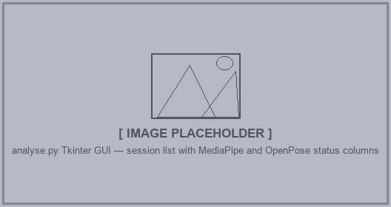
analyse.py Tkinter GUI — session list with MediaPipe and OpenPose status columns

9. plot_results.py
Purpose: Reads all processed result JSON files under data/processed/ and generates publication-ready group-level charts plus individual participant reports in data/plots/.
Depends on: matplotlib, numpy, json, pathlib
Used by: (terminal script — outputs are PNG files for the report)

Generated charts (data/plots/)
File | Description
01_model_comparison_mpjpe.png | Bar chart: MediaPipe vs OpenPose MPJPE per participant
02_per_finger_mpjpe.png | Mean per-finger MPJPE: MediaPipe L, MediaPipe R, OpenPose combined
02_per_finger_mpjpe_mediapipe.png | MediaPipe-only per-finger MPJPE: L and R panels
03_detection_breakdown.png | Stacked bar: matched / detection-fail / missed proportions per model
04_mpjpe_by_lux.png | MPJPE grouped by lighting condition (Dim / Indoor / Bright) with SD error bars
05_mpjpe_by_fitzpatrick.png | MPJPE grouped by Fitzpatrick skin type with SD error bars
06_mpjpe_vs_handsize.png | Scatter: MPJPE vs hand size (cm) with regression lines per model
07_finger_distribution_mediapipe.png | Box plots of per-finger MPJPE distribution across all sessions (MediaPipe)
07_finger_distribution_openpose.png | Same for OpenPose (combined L+R)
08_heatmap_mediapipe.png | Heatmap: participants x fingers, 10 columns (L/R split)
08_heatmap_openpose.png | Heatmap: participants x fingers, 5 columns (combined)
reports/p###_report.png | Individual participant report (see below)

Participant report layout
Panel position | Contents
Top left | Session info: PID, Fitzpatrick type, lighting, hand size, notes played
Top centre | Detection outcome bar chart (Matched / Det.Fail / Missed)
Top right | Overall results: MPJPE, accuracy %, detection rate for both models
Bottom left | Per-hand bar chart (MediaPipe) coloured by accuracy tier
Bottom centre | Per-hand bar chart (OpenPose) coloured by accuracy tier
Bottom right | Highlights: best/worst finger, detection rate rating, overall accuracy rating

Usage
python -m scripts.plot_results # all sessions
python -m scripts.plot_results --pid p001 p003 # specific sessions
python -m scripts.plot_results --out figures/ # custom output folder

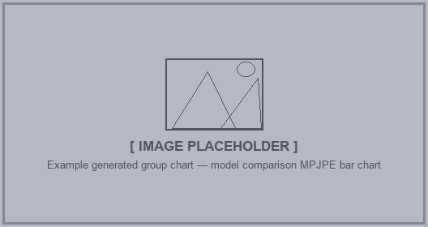
Example generated group chart — model comparison MPJPE bar chart

Example participant report — p001_report.png with all 6 panels

10. data_summary.py
Purpose: Quick audit of how much data has been collected across all sessions. Prints a table with per-session frame counts, MIDI event counts, and matched note statistics. Does not depend on any internal scripts.
Depends on: json, csv, pathlib
Used by: (standalone audit tool — no imports of project scripts)

python -m scripts.data_summary

Column | Description
Frames | Total video frames recorded in the session
MIDI evts | Total MIDI messages of all types
note_on | Key-press events with velocity > 0
MP matched | Notes where a MediaPipe fingertip landed inside the key polygon
OP matched | Notes where an OpenPose fingertip landed inside the key polygon

11. Dependency Graph
Arrows show import relationships. scripts at the top are imported by everything below them.

config.py
camera_setup.py
lux_calculator.py
fitzpatrick_detector.py
stats_collector.py
midi_recorder.py
key_calibration.py
| recalibrate.py
model_manager.py
| live_preview.py ............ (no data written to disk)
| analyse.py
| plot_results.py
record.py (imports all of the above)

data_summary.py (reads data/raw/ directly, imports no project scripts)

